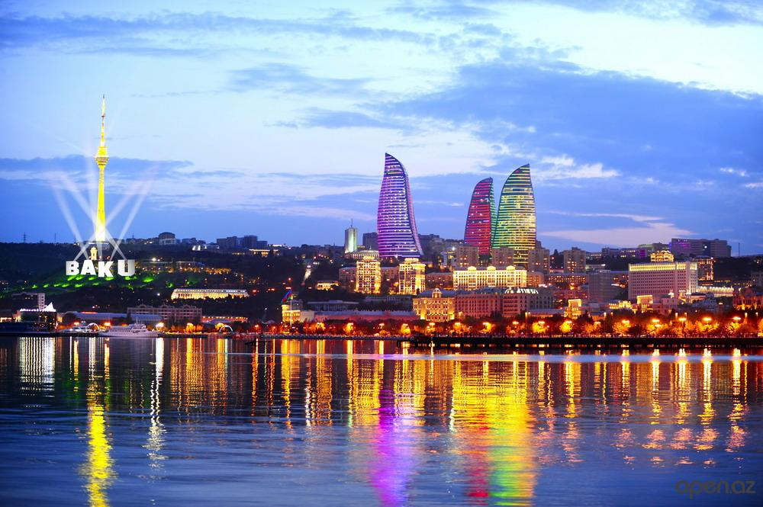
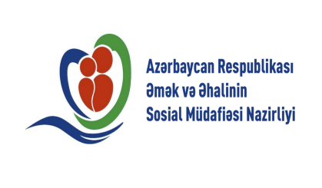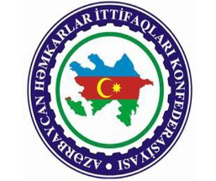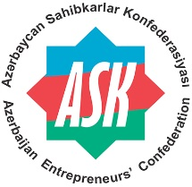

"Towards the Sustainable Development Goals:
promotion of
sustainable development and decent work”

International Conference

Azerbaijan, Baku
21 May 2018

ADMINISTRATIVE AND PRACTICAL INFORMATION NOTE

- Purpose
The Conference will allow participants to discuss important issues of interest or concern in ILO perspective and in the context of the 2030 Agenda, namely: Future of Work; Achieving an inclusive, sustainable and job-rich growth with focus on SDG 8; Transition from the informal to the formal economy; Monitoring SDGs implementation.
- Venue
The Hotel Fairmont Baku (Flame Towers 1A, Mehdi Huseyn, Baku, Azerbaijan AZ1006)
http://www.fairmont.com/baku/map/map-and-directions/
- Working language
The working languages of the event – Azerbaijan, English, Russian

- Deadline for Nominations
Nominations received after 10 May, 2018 will be not considered.
- Visa
It is the responsibility of participants to obtain the visa to attend this Conference, including any transit visas that may be necessary. In case of difficulties regarding the issuance of visas, the participants may request the host organization to send an invitation letter to assist the process.
Participants may take advantage of the new online ”ASAN Viza” e-visa system (https://www.evisa.gov.az/en/) to obtain a visitor visa for Azerbaijan. Applicants may obtain a standart e-visa within 3 working days. An urgent e-visa may be obtained within 3 hours any time. List of countries eligible for e-visa https://evisa.gov.az/en/countries
- Airport transfers
Airport transfers will be arranged for the Heads of delegations and delegates. The participants are requested to send the organizers their flight details until 15 May, 2018.
- Administrative and Financial Arrangements
Accommodation costs at Hotel Fairmont Baku (http://www.fairmont.com/baku/) during 20-22 May, 2018 (2 nights) for 2 persons (Head of delegation + 1) will be covered by the inviting organization. Accommodation expenses include room charge and breakfast. All other expenses with regard to accommodation would be assumed by respective delegations. Delegations wishing to change or upgrade their accommodations provided by the inviting organization will have to cover costs arising from any room change or upgrade.
Information about the delegates (name, surname, position) whose accommodation will be covered by the inviting organization, are kindly asked to email to respective contact person no later than 10 May, 2018.
- Meals
The organizers will provide lunch and official reception on the day of the Conference, and a welcoming dinner for all participants on 20 May, 2018.
- Liaison Officer/s:
Liaison officer will be attached to the Head of Delegation in case of the Minister or Deputy Minister level.
Help desk will be available at the entrance of Hotel Fairmont Baku, and will be responsible for assisting participants regarding logistics arrangements such as accommodation, transportation, and other related matters.

- Usefull information

Currency in Azerbaijan

National currency of Azerbaijan is manat (AZN). The face values of the banknotes are 1, 5, 10, 20, 50 and 100 manat, while those of the coins are 1, 3, 5, 10, 20 and 50 gepik. Major foreign currencies can be converted to and from AZN in the banks. International credit cards are accepted for transactions and retrieving cash. ATMs are available in all shopping malls, banks, hotels etc.
13.04.2018
1 USD - 1.7000 AZN
1 EUR - 2.0958 AZN

Azerbaijan Mobile Operators codes are the following:

Azercell Telecom  GSM standard  International code: +994 050/051  www.azercell.com | Bakcell  GSM and UMTS standard  International code: +994 055  www.bakcell.com | Nar Mobile (Azerfon)  GSM standard  International code: +994 070/077  www.nar.az

Useful phone numbers in Azerbaijan.
Information services of Azerbaijan “119”  Tel: 012 119 | Baku Inquiry office  Tel: 109 | Bus station inquiry office  Tel: 499-70-38/39
Airport inquiry office  тел.: 497-27-27 | Railway station inquiry office  тел.: 493-93-66 | Sea port inquiry office  тел.:493-08-68

Climate
During the conference, the temperature is expected to be around 22 °C.

Contact persons
Ministry of Labour and Social Protection of Population | Azerbaijan Trade Unions Organization | Azerbaijan Enterpreneurs’ Confederation
Ms. Ayshan Khasiyeva  Tel: +994 12 541 98 04  ayshan.khasiyeva@mlspp.gov.az  Mr. Farid Garayev  Tel.:+994 12 541 98 04  farid.garayev@mlspp.gov.az | Mr. Fuad Mammadov  Tel: +994 12 497 08 23  fuadmammadov.ahik@gmail.com | Ms. Tarana Mammadova  Tel: +994 12 465 72 42  tmammadova@ask.org.az  Mr. Javid Karimov  Tel: +994 12 465 72 42  ckarimov@ask.org.az

